Web Development – Mr. Turner

Project – Slider Puzzle

**Project Overview**

Write a simple slider game where the user puts numbers in order by moving “tiles” around.

**Display**

The list below includes the essential elements of the page.

* The page should be dressed up using CSS.
* Instructions.
* A start button.
* A reset button.
* An output area that shows the number of moves the player has made toward solving the puzzle.
* There should be a board with 16 spaces and 15 numbered tiles. You may use any style or colors you like. You may use a table.

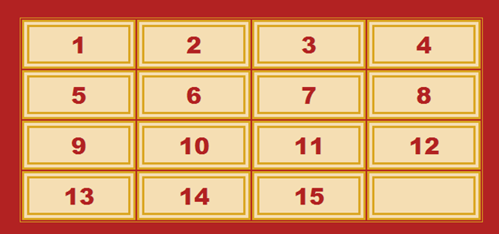

**Functionality**

The page opens with the puzzle in its solved state. The user will have to shuffle it manually.

*Note that a puzzle like this cannot be randomly shuffled. If the pieces are simply taken off the board and replaced, they may be done so in a way that makes it impossible to solve the puzzle.*

The user clicks on one of the numbers adjacent to the empty tile and that number moves to the empty space, leaving its original space vacant.

Clicking on tiles that are ***not*** adjacent to the empty space will have no effect.

After the user is finished shuffling, (s)he should click the start button. The number of moves will be set to 0. At that point, the program will start counting moves. Every time the user clicks and successfully moves a number into a blank spot, the number of moves will increase.

When the user clicks reset, the page will stop counting moves. Remember that the number of moves does not reset to 0 until the start button is clicked.

Update the display accordingly.

The game should tell the user when (s)he wins.

**Enhancements**

* Create a shuffling function which will only be available when the puzzle is completely solved. It will shuffle the board by making 1000 random moves.

**Programming Skills**

* Comprehension of the specifications sheet.
* Manipulating back end information and representing it properly in the display.
* Using HTML and CSS to create a pleasant and intuitive display.